Lecture: 3.2.2
Basic operations: NOT (-) Truth value of a compound statements
Course outcome to be covered:
CO1: Apply and recognized about the Logics

Negation/ NOT (¬)
Negation (¬) − The negation of a proposition A (written as ¬A) is false when A is true and is true when A is false.
The truth table is as follows −
A | ¬ A
True | False
False | True

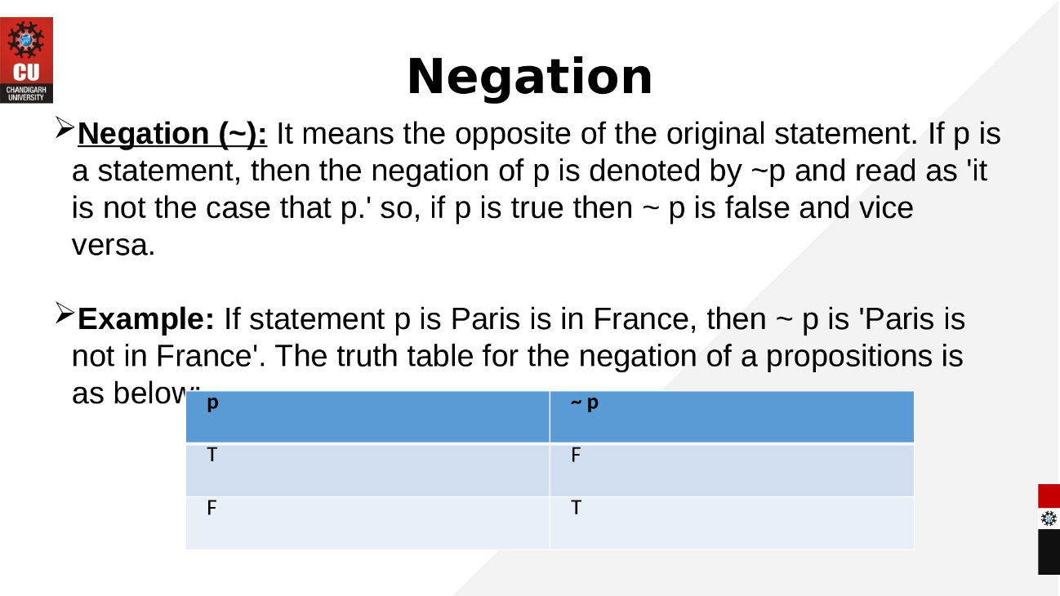

Implication / if-then (→) − An implication A→B is the proposition “if A, then B”. It is false if A is true and B is false. The rest cases are true.
The truth table is as follows −

A | B | A → B
True | True | True
True | False | False
False | True | True
False | False | True

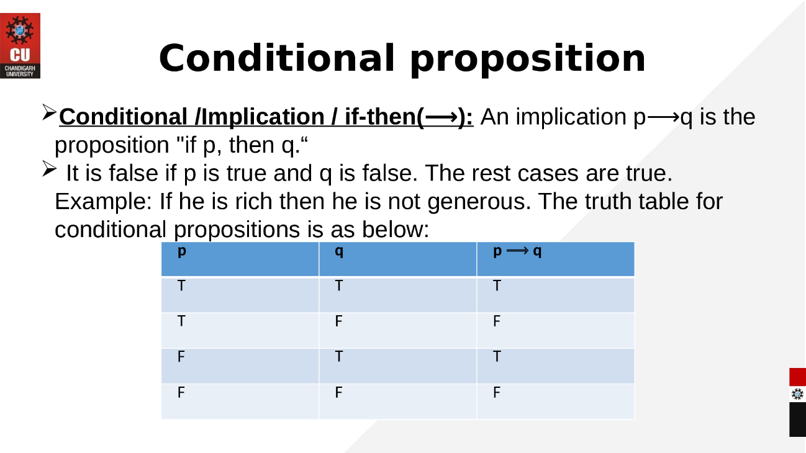
If and only if (⇔) − A⇔B is bi-conditional logical connective which is true when p and q are same, i.e. both are false or both are true.
The truth table is as follows −
A | B | A ⇔ B
True | True | True
True | False | False
False | True | False
False | False | True

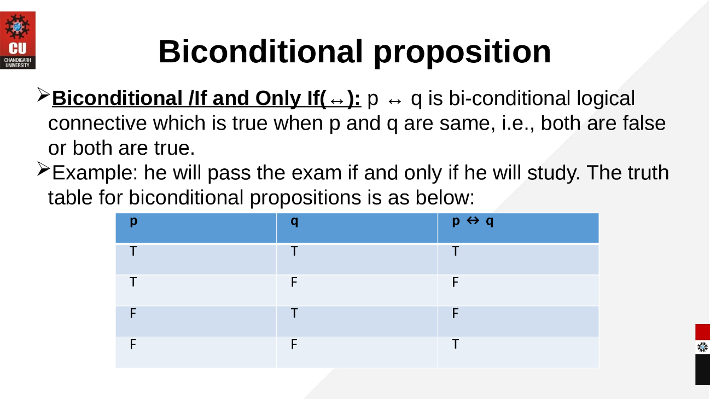
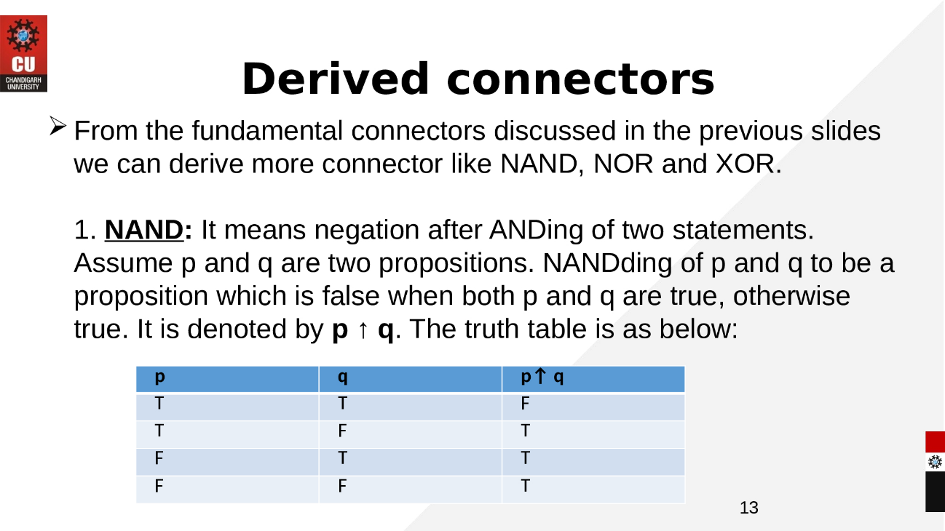
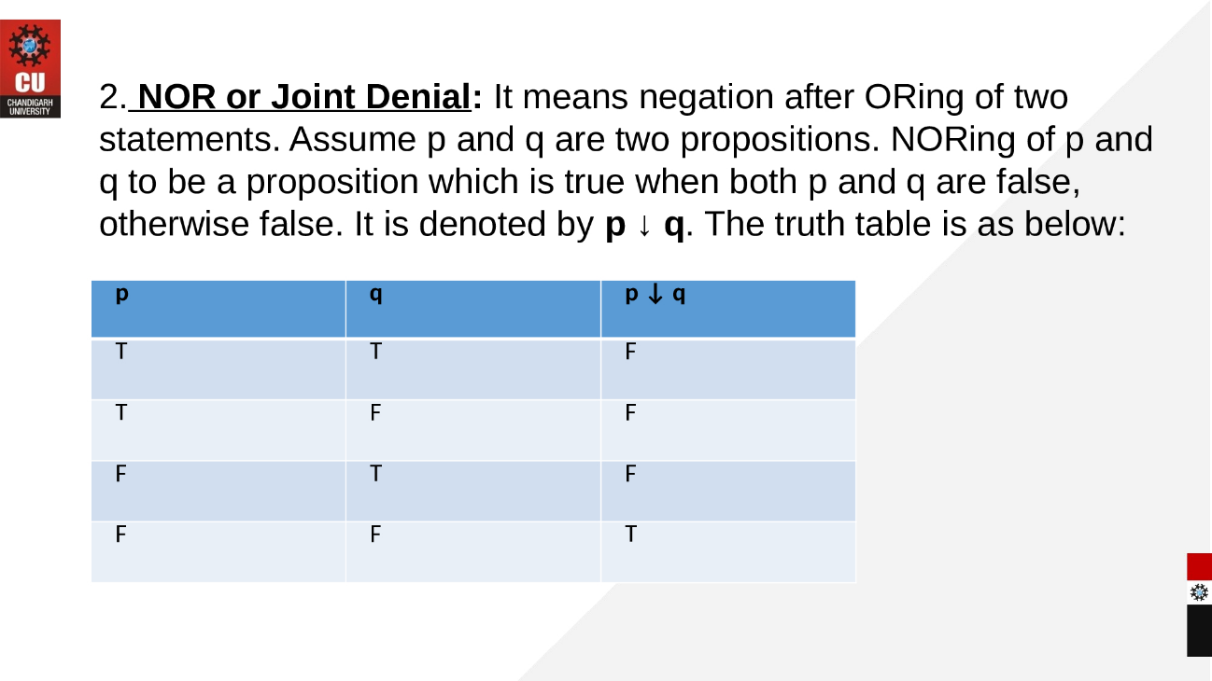

Links: https://www.youtube.com/watch?v=Mks4yjKTkwo
eBook Discrete Mathematics
https://old.amu.ac.in/emp/studym/99998829.pdf

